Website Planning Document
Site: The Temple Inn & Suites

Site Purpose: The Temple Inn & Suites is a five-star Hotel on the beautiful Pacific coast of
Ecuador. nn

Domain: templeinnandsuites.com

Target Audience: This web page will be directed especially for the family, but also for
businessmen who come in search of tranquility and an appropriate place to close their
businesses, therefore it will be provided with luxury family suites as well as suites for one person
or couples who have the need to visit this beautiful city.

Site Map:

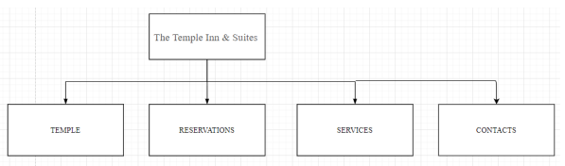
Color Scheme:
Blue
Gray
Golden
White

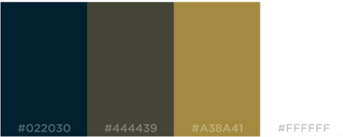

Typography:
Google Fonts
font-family: 'Open Sans', sans-serif;
Wireframe:
LARGE

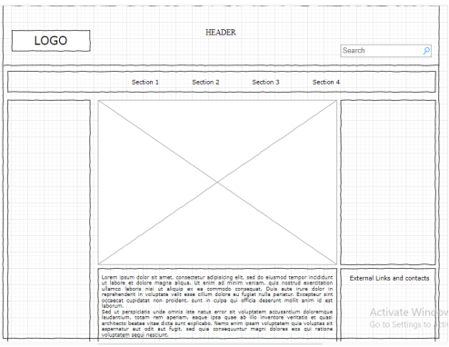

MEDIUM AND SMALL

